Psycho-sociological aspects of leadership; Class 2

12/09/2018

# Motivation & Empowerment

## 1/self-esteem

Work is important to make sense

Recognizing work importance in our lives:

- Time, relationships, a source of identity.

- It must make sense to us.

Work allow to :

* Enhance skills
* Enrich ideas
* Make choices and organize your time
* Get pleasure

Challenges people face in the workplace:

- Desire to be recognized and respected

- Will managers of a company help them achieve their aims?

Submarine case : you need to keep everybody busy, happy, in a problem free world

-> though and responsible job : he is capable and trustable.

One of the most important thing as a team manager is recognizing the importance of the people and timing. Making them share what they learned is important for team cohesion, for example during the party of celebration of a new successful project.

If someone feel frustrated, you have help them reframe.

If someone calm -> might scapegoat of the team, self fulfilling prophecy

## 2/ Pygmalion Effect

Unmotivated speech vs motivational one. A confidence boost happened to the one with the motivational speech. Experience on school children in California

As a team manager; the highest your expectation of someone, it helps them to keep on track to achieve it. If you give a negative label then people will internalize it and perform accordingly.

If someone is shouldering a lot of the blame -> help it

If someone is quiet, don’t push them to speak publicly but encourage to speak in a comfortable place.

The greater the expectation placed on someone, the better they perform.

--> But if you assign a negative label, people will internalize it: self-fulfilling prophecy.

Reality can be influenced by expectations of others.

--> Beneficial or detrimental, according to label an individual is assigned.

The effect of observation / expectation also involves an inherent bias on the part of the observer.

## 3/Maslow

Need for achievement:

- Having autonomy

- Participating in decision-making

- Making progress, training

-Work becomes a source of self-expression

Need for recognition - esteem:

- Capability of expressing skills

- Receiving signs of recognition, congratulations, encouragement

- Having responsibilities regarding key tasks

Need to belong, to adhere:

- Possibility of having relationships

- Integration in a team, team spirit

- Dialogue that is possible and agreeable with colleagues and superiors

Need for safe working conditions:

- Job security

- Lines of command, supervision, planning

- Methods, work routines

Material needs - physiological:

- Correct and fair pay

- Work incentives

- Material working conditions (agreeable environment, breaks, reasonable working hours)

## 4/Herzberg

Factors in the work-place - Impersonal :

* Salary, work conditions, policies.
* Cool if you get it but won’t get you to be motivated.
* Remove them and get dissatisfaction

Factors of motivation - Personal :

* Challenges on job
* Responsibilities, promotions, personal development
* If got them may generate satisfaction
* Can be adapted to the individual

## 5/Theories X and Y by Mac Gregor

Theory X :

People doesn’t want to work, avoid it.

Carrot/Stick method

Theory Y :

In good condition humans seek and accept responsibilities

Mental effort for manager to find challenges for each of them so they give their best

People are associate with the objective of the company

Article of faith

## 6/Flow

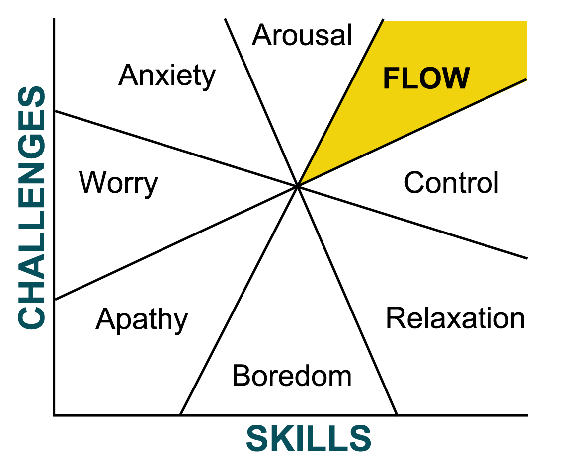

## 7/ Dan pink & Motivation

Sense of belonging to something bigger than self

Learning something challenging

Enjoy experience of unique challenge

RSA animate video : notes

<https://www.youtube.com/watch?v=u6XAPnuFjJc>

If you reward something you get more of the behaviour you want :

works only has long as it use only mechanical skill, straightforward task. Indeed the higher the pay the better the performance

If the task called for rudimentary cognitive skill -> poorer performance

Money is a motivator

No money -> people won’t be motivated

Best use as a motivator is to pay people enough so that issue of money is no longer one

3 factors lead to better performance & personal satisfaction :

* Autonomy : desire to be self-directed
  + Traditional management wants compliance
  + If you want engagement self direction is better
  + Ex : Atlassian with a 24h day work how you want, on what you want, just show results. Fun meeting -> fixes, new ideas
  + People probably want to do something interesting, just get out of their way
* Mastery
  + To get better at stuff
  + Ex : play music on weekend -> fun, better at it is satisfying
  + Ex: open-source : skilled work, for free, volunteer their time, creation is given away -> linux, apache, wikipedia, …
  + Why ? They have jobs but yet in their free they do even more for someone else for free
  + Challenge, Mastery & Making a contribution
* Purpose
  + Wanted by organisations
  + Work better and better talent
  + Profit motive creates bad services and crappy product
  + Companies are flourishing with purpose motive
  + Ex: Skype : world better place
  + Purpose maximisers

With science and organisation and work life we can be better off. We can make the world just a little bit better

# Situational Management

2 criteria : degree of competence & degree of motivation

Level of Autonomy:

Very low -> Low -> Moderate -> High

Management Style :

Directive -> Persuasive -> Participative -> Delegation

Role :

Structure ->Train & Explain -> Associate -> Responsibility

Directive (diapo 43): Very low autonomy

- Role: structure

- Decisions: made by the manager

- Behavior:

--> Very organizational

--> Not very relational

- Effective if:

--> Temporary

--> Crisis situation

--> Neutral tone

--> Employees wihout a lot of experience

- Key words: "I"

- Actions:

--> Organization

--> Planning

--> Checking

Persuasive (diapo 44): Low autonomy

- Role: Mobilize, train & explain

- Decisions: made by the manager

- Behavior:

--> Very organizational

--> Very relational

- Effective if:

--> Sincere, authentic, not manipulative

--> Creating a team, building a project

--> Accompanied by a minimum amount of participation

- Key words: "I" + "We"

- Actions:

--> Explanation

--> Persuasion

--> Conviction

--> Exemplary

Participative (diapo 45): Moderate autonomy

- Role: Associate, making real choices

- Decisions: decision-making is shared by the manager

- Behavior: manager listens, negotiates and builds partnerships

--> Not very organizational

--> Very relational

- Effective if:

--> Contracts are respected

--> Decision-making is really shared

--> Listening and advice is available to people

- Key words: "I" + "You" + "We"

- Actions:

--> Listening

--> Advice

--> Arbitration

--> Partnership

--> Negotiation

Delegating (diapo 46): High autonomy

- Role: Giving people responsibility

- Decisions: done by the team or the person

- Behavior:

--> Not very organizational

--> Not very relational

- Effective if:

--> Corresponds to shared responsibility

--> Delegating is well-balanced

--> Allows the employee to gain experience

- Key attitudes: how the manager acts, not so much what he / she says

- Actions:

--> Responsibility

--> Initiative

--> Risk

--> Evaluation

# The challenge of interpretations

Listening is a leaders quiet confidence at work.

Strategic listening (diapo 49):

--> Whats my intuition?

--> Environment/Context

--> Listening to my team members problem

Developing active listening: reformulating.

- Mirroring: Use key words your client says

- Take just a phrase, a part of a phrase, one/two key words

The Language Compass :

- Facts

- Rules

- Supposing

- Judgments

--> Generalizations

Feelings towards the person you are managing (diapo 55).

Quality of our decisions depends on:

- Observations:

--> Deductive learning: establishing the evidence concerning a situation

--> Personal perceptions based on our 5 senses

- Inferences:

--> Inductive learning: starting with our hypothesis and see where it leads us

--> Make decisions based on what we think something means.

--> Not always aware that we are actually making decisions this way.

Both approaches are indispensable for reaching a decision. Yet we confuse them.

--> Not being clear about this distinction leads to a lot of defective decisions that have an impact on operational effectiveness.

6 Listening channels :

* Evaluation :
  + Sensation of inequality
  + Inhibition
  + Worry of being judge
* Solution
  + May not be adapted to solution
  + May feel like taking charge
  + Will feel misunderstood
* Support
  + Mark of friendship or hostile rejection
  + Don’t want pity
  + May become dependent if accept
* Investigation
  + May be accepted
  + Vue as interrogation
  + Motivation critical to gaining or losing trust
* Interpretation
  + Clarification of situation
  + Provoke defense mechanism
  + Risk of misunderstanding
* Understanding
  + Listened to and recognized
  + Details about intentions
  + Express in greater depth

“SO WHAT'S NEXT? “